**Instructions for the physician**

**Equipment:**

The linked equipment below are just examples. They can be replaced with other brands

**However, the Avery Print/Write Self-Adhesive Removable Labels, 0.75 Inch Diameter, Red is required and cannot be replaced unless the desktop algorithm is manually changed to detect a different color and size.**

* Tripod <https://www.amazon.com/AmazonBasics-60-Inch-Lightweight-Tripod-Bag/dp/B005KP473Q/ref=sr_1_3?dchild=1&keywords=tripod&qid=1588460003&sr=8-3>
* Smartphone Tripod Adapter <https://www.amazon.com/Vastar-Universal-Smartphone-Horizontal-Adjustable/dp/B01L3B5PBI/ref=sr_1_3?crid=328K86Z3ZNKLY&dchild=1&keywords=iphone+tripod+adapter&qid=1588460076&sprefix=iphone+tri%2Caps%2C191&sr=8-3>
* Avery Print/Write Self-Adhesive Removable Labels, 0.75 Inch Diameter, Red

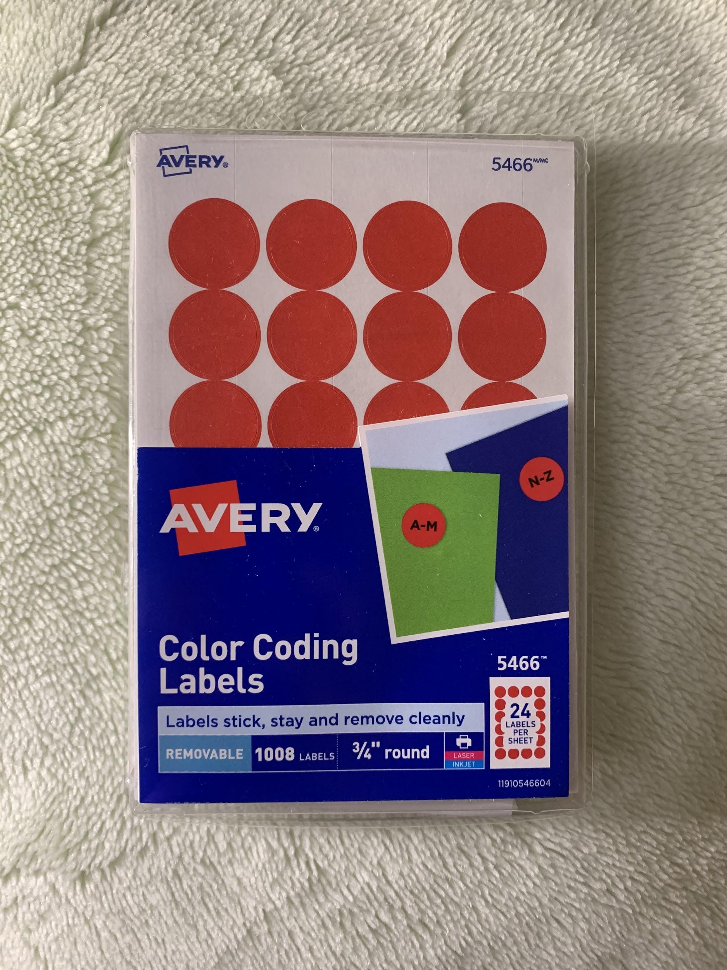<https://www.amazon.com/Avery-Self-Adhesive-Removable-Labels-Diameter/dp/B00007LPAG/ref=sr_1_5?dchild=1&keywords=avery+label+red&qid=1588460035&sr=8-5>

* (Optional, needed if the room is not well-lit) Lighting equipment <https://www.amazon.com/TaoTronics-Portable-Desk-Lamp-Dimmable/dp/B07S1P3HZC/ref=sr_1_10?dchild=1&keywords=led+lamp&qid=1588460159&sr=8-10>

**Instructions:**

1. Download **all** **the files** for the desktop app in the **Desktop App** folder from https://github.com/tammi-p/JVP and put the files under a folder that will be specifically used for amplifying videos

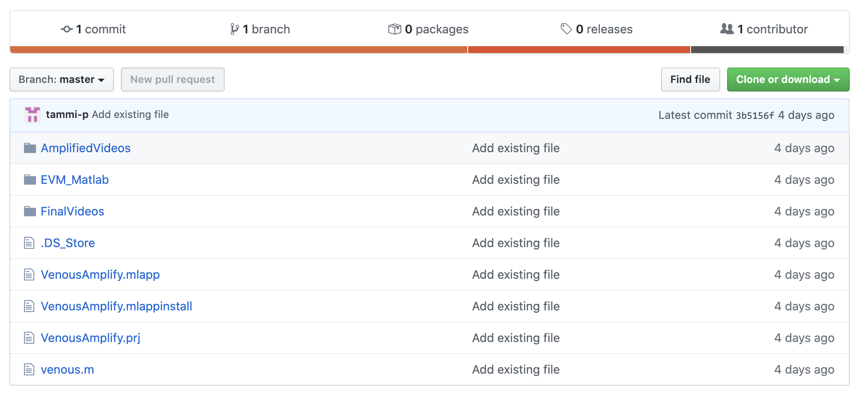

1. Click on **VenousAmplify.mlapp** to open the desktop app

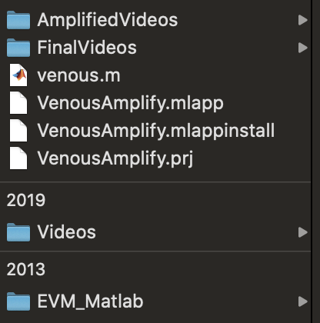

1. After a few seconds Matlab and UI Figure will pop up

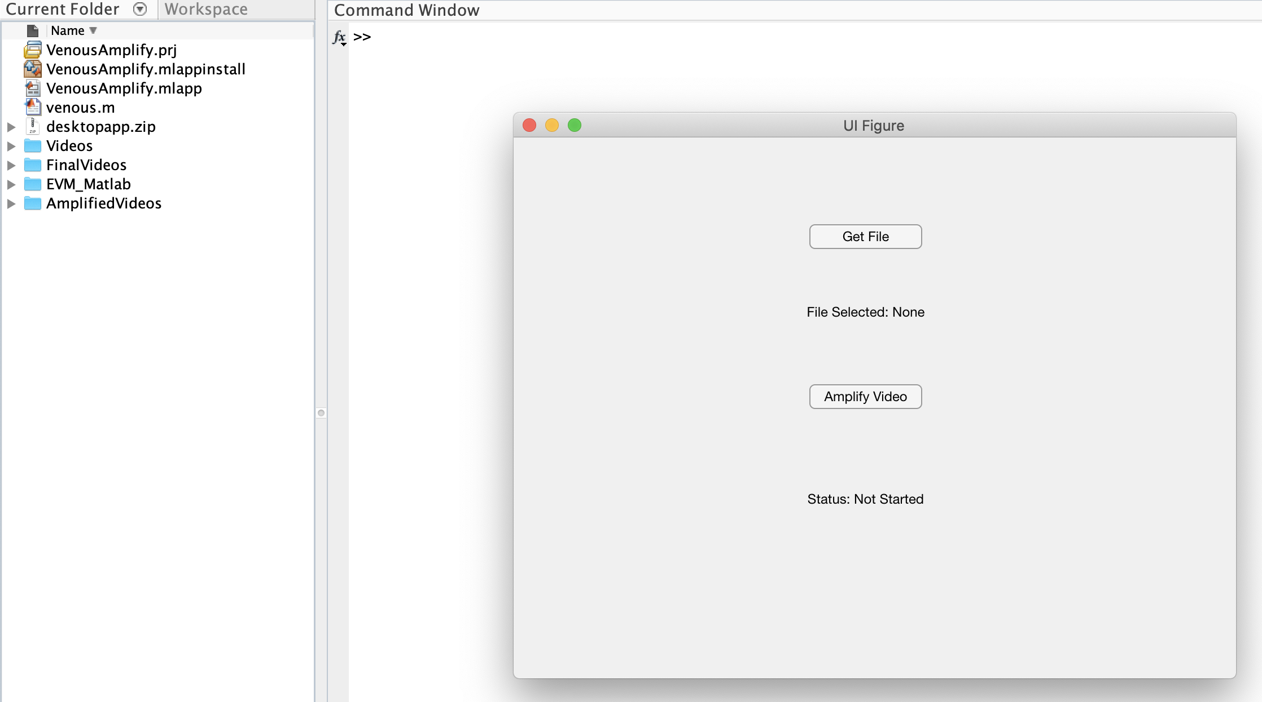

1. Click on **Get File** in UI Figure and select the video you want to amplify
2. After selecting the video, click **Amplify Video**
3. The status will change to **Processing** (The Command Window will show the processing percentage)

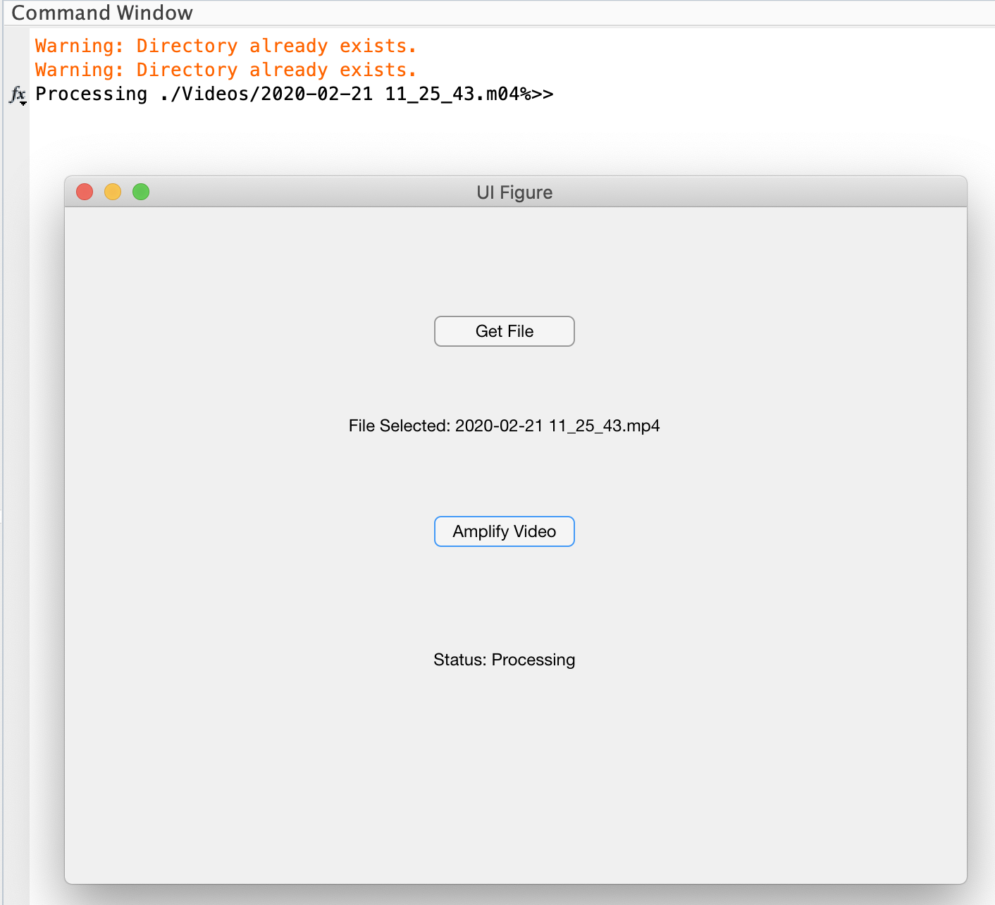

1. Wait until the status changes to **Finsihed**

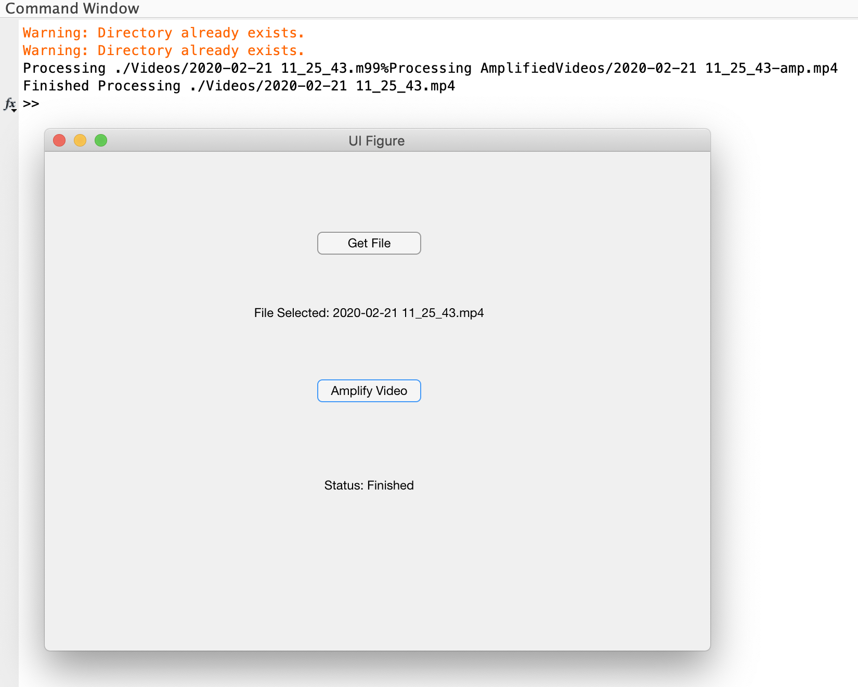

1. The amplified video with the reference distances will be outputted into the **FinalVideos** folder
2. In the **AmplifiedVideos** folder, there will be the same amplified video, but without the reference distances

**Misc. Info:**

* The iOS app does not need to be used if you want to record a video manually
* Recommended settings for recording manually
  + 1080p 30 fps Processing time for the desktop app will be around 8 min
  + 1080p 60 fps Processing time for the desktop app will be around 15 min
  + 720p 30 or 60 fps This will still work, but the quality will decrease compared to the above
  + Can record vertically or horizontally, but vertical is recommended